**Fiscal Policy Quiz**

1. Define fiscal policy.

the government using taxes and spending money to try to help the economy

1. Fiscal policy is part of demand-side economics developed by which famous economist during the Great Depression?

keynes

1. What are the two tools of fiscal policy?

government spending and taxes

1. Who administers or carries out fiscal policy?

the government and more specifically congress

1. Programs that automatically trigger benefits if changes in the economy threaten people’s income are called what?

automatic stabilisers

1. Define supply-side economic policy.

an economic policy thats used to try to increase output

1. Which President of the the United States advocated supply-side economic policies?

reagan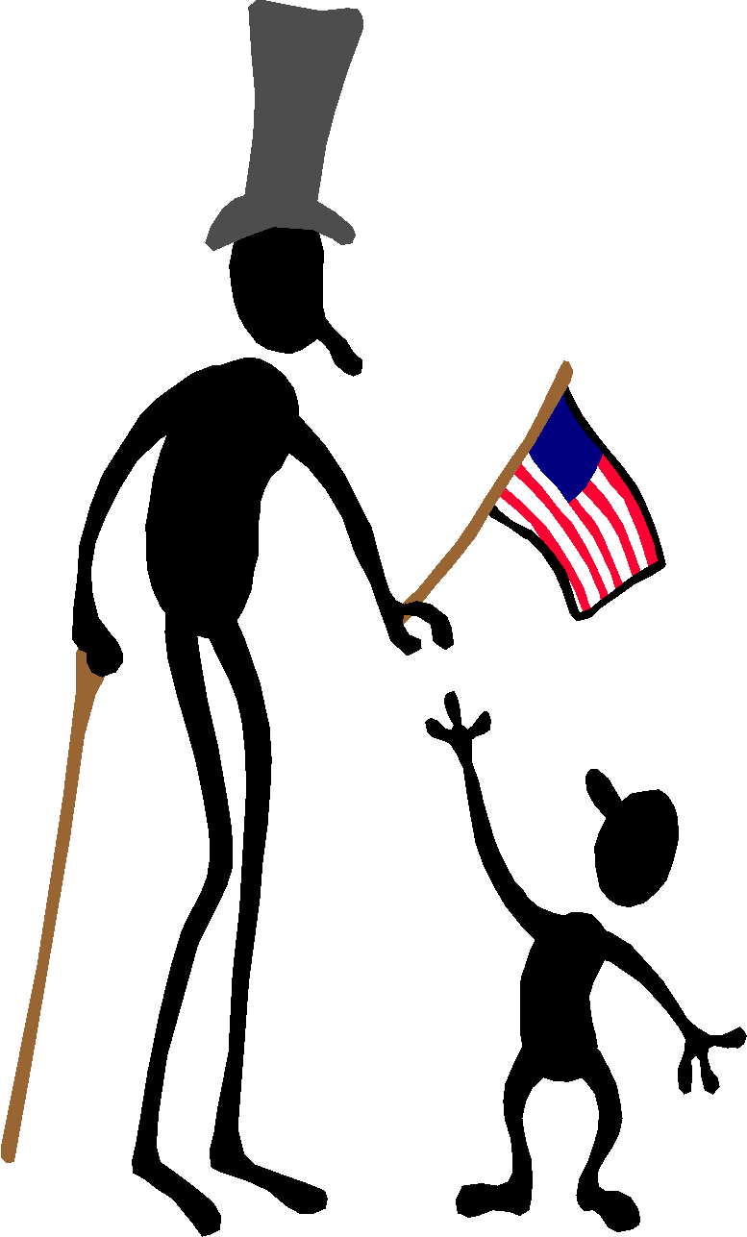

**Using fiscal policy:**

1. If you need to fight inflation, would you increase or decrease government spending? decrease
2. If you are trying to stop a recession, would you increase or decrease taxes? decrease
3. If you are fighting inflation, would you increase or decrease taxes? increase
4. If you are trying to stop a recession, would you increase or decrease government spending? increase
5. Is the fiscal policy used to stop a recession expansionary or contractionary? expansionary
6. Is the fiscal policy used to fight inflation expansionary or contractionary? contractionary

**Contract or expand? What effect will the following government actions have on the overall economy if taxes are unchanged?**

1. The Army buys additional tanks. expand
2. Welfare and Medicaid payments increase. contract
3. NASA’s funding is cut back. contract
4. Five percent of all post offices are closed. contract
5. Government work force is decreased by 15%. contract
6. The age for receiving Social Security payments is raised. expand
7. Additional funds are provided to the U.S. Border Patrol to fight illegal immigrants. expand